DKM COLLEGE FOR WOMEN(AUTONOMOUS)
VELLORE-1
REPORT ON THE
CITIZEN CONSUMER CLUB(CCC) ACTIVITIES
FOR THE ACAEDEMIC YEAR 2017-18

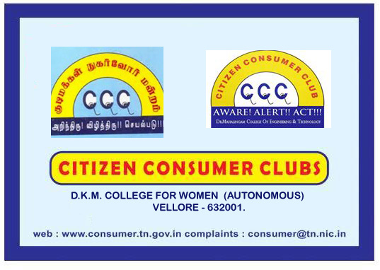

report of the ccc activities for the
academic year 2017-18

The activities of citizen consumer club of DKM college was inaugurated on 4th September 2017. All the B.Com students of Aided pattern are the members of the CCC. Under the headship of the CCC CO ORDINATOR, DR.A.SUDARVIZHI the activities of the CCC was inaugurated. Ms. U.SUVALAKSHMI , III B.Com, was selected as the student secretary of CCC for this academic year. Mrs. A.Sudarvizhi spoke on the basic concepts, rights and duties of a consumer with a power point presentation. The other events organized were as follows.

DATE | EVENTS ORGANISED | No. of beneficiaries
4. september.2017 | Inaugural function of CCC activities for the academic year 2016-17 | 50
30.SEPTEMBER.2016 | A seminar on Consumer Protection Act, 1976 | 50
17.October.2017 | Students seminar on the effects of junk foods | 50
23 January 2018 | Participated in the competitions on FRAUDS ON ONLINE SHOPPING organized by Vellore Collectorate, Vellore | 15

PROPOSED FUTURE PLANS OF CCC
- To observe the NATIONAL CONSUMER DAY
- To observe the WORLD CONSUMER DAY
- To conduct competitions relating to consumer awareness
The name board of the CCC is already displayed in the entrance of the college in such a way so that not only it is easily visible to all but also educating the students as well as the society about the existence of such important club in our college.
DKM college is supplying RO purified water to the students round the clock. Also we have the provision for Rain Water Harvesting in our college. The cleanliness of the campus is taken care by the members of the Enviro club of DKM college and the members of CCC.
