DKM COLLEGE FOR WOMEN(AUTONOMOUS)
VELLORE-1

REPORT ON THE
CITIZEN CONSUMER CLUB(CCC) ACTIVITIS
FOR THE ACAEDEMIC YEAR 2019-20
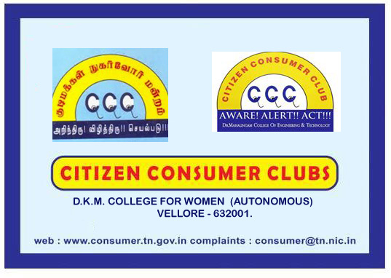

report of the ccc activities for the
academic year 2019-2020

The activities of citizen consumer club of DKM college was inaugurated on December 2020. All the students of DKM college are the members of the CCC. Under the headship of the CCC CO ORDINATOR, DR.A.SUDARVIZHI the activities of the CCC was inaugurated. Ms INDUMATHI, III B.Com, was selected as the student secretary of CCC for this academic year. On 25th February 2020 as per the instructions received from the JD office, Inter-college competitions were conducted. Nearly 10 colleges from vellore district participated. Competitions were organized and the report was sent to JD office.
