DKM COLLEGE FOR WOMEN(AUTONOMOUS)
VELLORE-1

REPORT ON THE
CITIZEN CONSUMER CLUB(CCC) ACTIVITIES
FOR THE ACAEDEMIC YEAR 2020-21
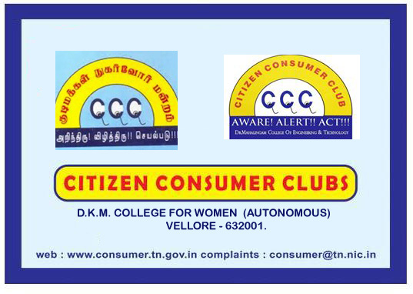

report of the ccc activities for the
academic year 2020-2021

The activities of citizen consumer club of DKM college was inaugurated on 18th December 2020. All the students of DKM college are the members of the CCC. Under the headship of the CCC CO ORDINATOR, DR.A.SUDARVIZHI the activities of the CCC was inaugurated. Ms.U.DIVYA, III B.Com, was selected as the student secretary of CCC for this academic year. Dr.T.Bharathi, Assistant Professor of Commerce(Aided) spoke on the basic concepts, rights and duties of a consumer with a power point presentation. The other events organized were as follows.

S.NO | NAME OF THE ACTIVITY | CHIEF GUEST | NO OF BENEFICIARIES | Date
1. | Consumer Awareness Meeting on consumer rights and responsibilities | 1.Thiru.T.Basherruddin, M.A, Consumer Activist,Founder president of consumers welfare protection society of pernambut, gudiyattham. | 100 | 16.02.2021
2. | Consumer Awareness Meeting on responsibilities | 2.Mr.K.Kumaresan, LLB, President-NCPA, State Joint Secretary-FEDCOT | 100 | 16.02.2021

Report on the awareness meeting on consumer rights & responsibilities held on TUESDAY the 16th february 2021 at 10.00 am at the brahamaputra conference hall.

The Department of Commerce(Aided) on behalf of the Citizen Consumer Club conducted an awareness programme of consumer rights & responsibilities on 16.02.2021 Tuesday in the Brahamaputra hall. Mr.K.Kumaresan, LLB, President-NCPA, State Joint Secretary-FEDCOT was the chief guest of the day. He spoke on the various rights and responsibilities of a consumer with pratical examples. he highlighted how a buyer should be aware and concentrate on what things while purchasing a product. at 11.30 am Thiru.T.Basherruddin, M.A, Consumer Activist,Founder president of consumers welfare protection society of Pernambut, Gudiyattham took over the stage. He shared the basic features of a consumer and the various remedies available to a consumer if they are betrayed or cheated. students also asked many questions and raised many doubts which was addressed by the resource person.
An intra college competition on misleading advertisement was conducted for the students. the competitions include drawing, essay writing and poetry. 52 students participated in drawing competition, 11 students in poetry writing and 50 students in essay writing. 2 judges for each category gave their judgment and the final winners for first three places were selected. prizes were distributed to the prize winners. Nearly 100 students participated in the meeting. Ms.P.Indhumathi, Co-ordinator of CCC from unaided pattern gave the vote of thanks. After the feedback from students the meeting ended at 1.00 pm.

PHOTOS

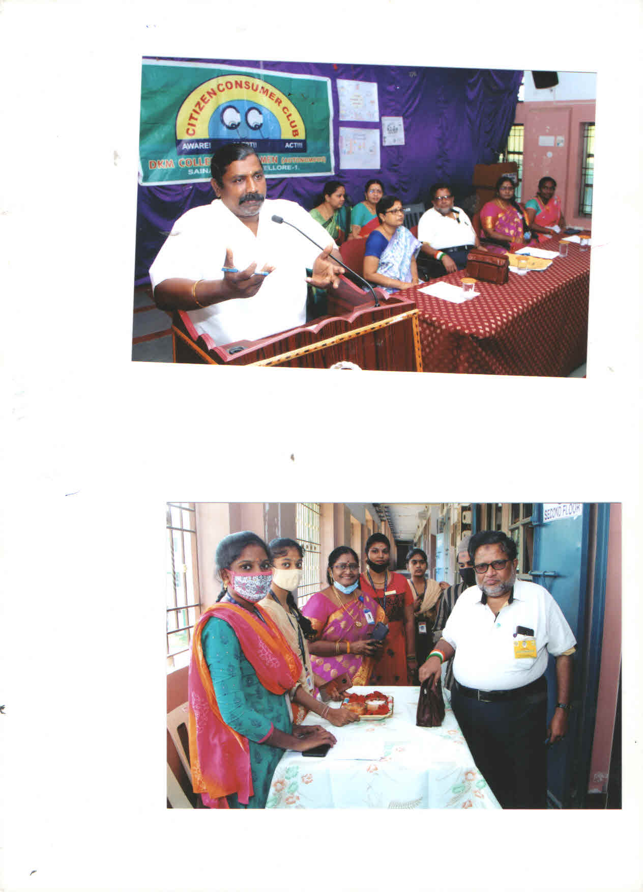

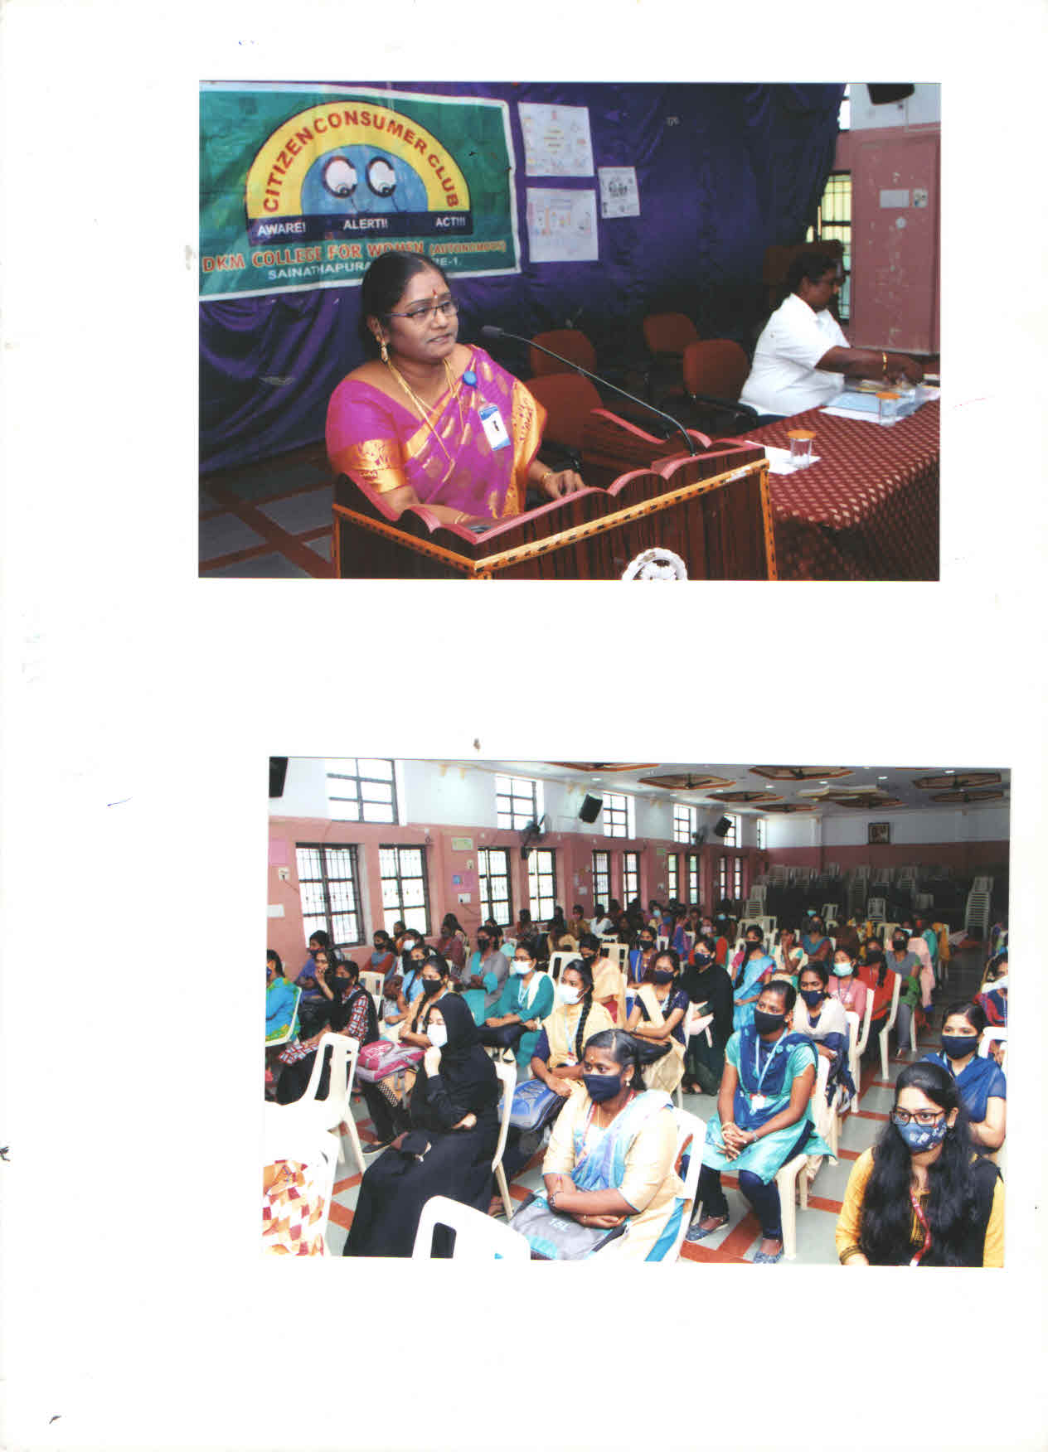
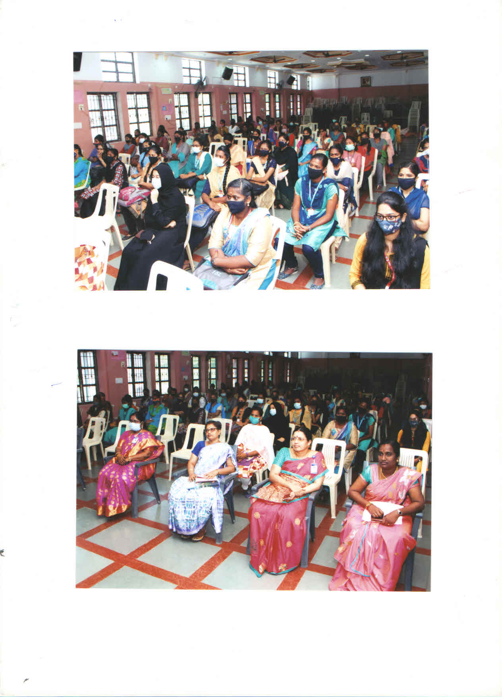

PRESS-PAPER CUTTING

