DKM COLLEGE FOR WOMEN(AUTONOMOUS)
VELLORE-1

REPORT ON THE
CITIZEN CONSUMER CLUB(CCC) ACTIVITIS
FOR THE ACAEDEMIC YEAR 2021-22
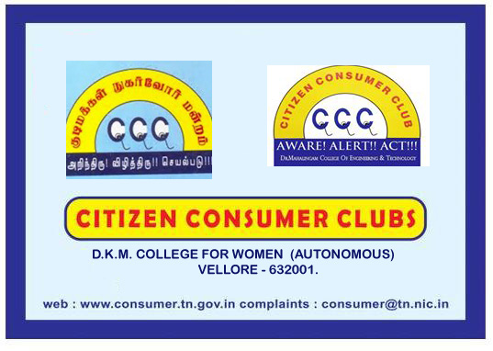

report of the ccc activities for the
ACADEMIC YEAR 2021-22

The activities of Citizen Consumer Club of DKM College was inaugurated on 2nd March 2022. All the students of DKM College are the members of the Citizen Consumer Club. Under the headship of the CCC CO ORDINATOR, Dr.K.Vinithi the activities for the academic year 2021-22 was inaugurated. Ms.U.Kokila, III B.Com, was selected as the student secretary of CCC for this academic year. The other events organized were as follows.
S.NO | NAME OF THE ACTIVITY | CHIEF GUEST | NO OF BENEFICIARIES | DATE
1. | Consumer Awareness Meeting on ‘Consumer rights and responsibilities’ | 1.Thiru.A.Kamaraj, District Supply and Consumer Protection Officer, Vellore. | 200 | 23.03.2022
2. | Frauds faced by consumers in day today life | 2.Mr.K.Kumareswaran, LLB, President-NCPA, State Joint Secretary-FEDCOT.

Report on the awareness meeting on consumer rights & responsibilities held on TUESDAY the 23rd march 2022 at 10.00 am at the brahamaputra conference hall.

Citizen Consumer Club conducted an awareness programme on “Consumer Rights & Responsibilities on 23.03.2022, in the Brahamaputra Hall. 200 students from various department participated in the meeting.
Thiru.A.Kamaraj, District Supply and Consumer Protection Officer, Vellore acted as resource person for this session. He shared his personal experience with the students and made them aware about the rights of a consumer. He also highlighted how a buyer should be aware and concentrate on what things while purchasing a product.

Mr.K.Kumareswaran, LLB, President-NCPA, State Joint Secretary-FEDCOT was the chief guest for the second session. He shared the basic features of a consumer and the various remedies available to a consumer if they are betrayed or cheated. Students also asked many questions and raised many doubts which were addressed by the resource person.
One the eve of this programme, essay competition, poetry competition and drawing competition was conducted from 14.03.2022 to 18.03.2022 on
a. Food Safety and Standards Act 2019 India
b. Food Safety and Standards Authority of India (a maximum of 6 pages in A4 size paper)
c. Any other topic relevant to Consumer Awareness.
The competitions include drawing, essay writing and poetry. 38 students participated in drawing competition, 5 students in poetry writing and 46 students in essay writing. 2 judges for each category gave their judgment and the final winners for first three places were selected and prizes were distributed to the prize winners. The details of the prize winners are as follows:
DKM COLLEGE FOR WOMEN [AUTONOMOUS], VELLORE-1
CITIZEN CONSUMER CLUB
Competitions conducted from 14.03.2022 to 18.03.2022
S.No. | Competition | Name of the Student | Class | Position (Prize)
 | Drawing | Roobini.V | II B.Com | First
 |  | Deepa .S | III B.Com | Second
 |  | Aarthi.M | II B.Com | Third
 | Kavithai | Gayathiri.C | III BBA | First
 |  | Shobana.R | III B.Com | Second
 | Essay | Saranya.S  Divya.V | II B.Sc Chemistry | First
 |  | Sathya Priya.S | II B.Com | Second
 |  | Jabin.K | I B.Sc ISM | Third

CLUB COORDINATOR

PHOTOS

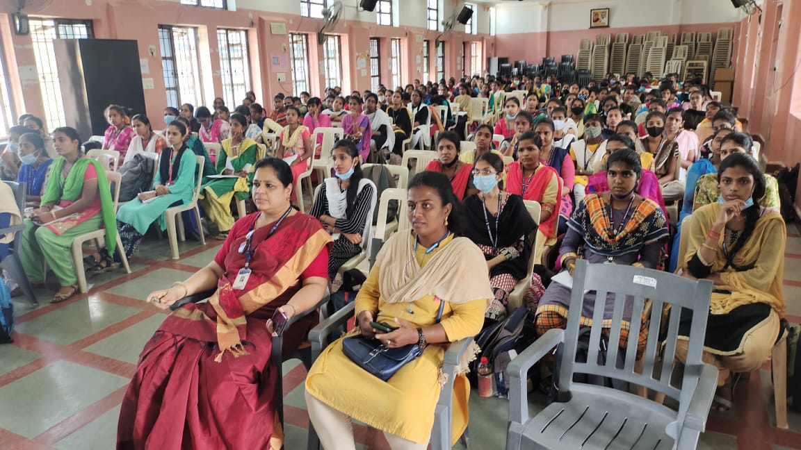

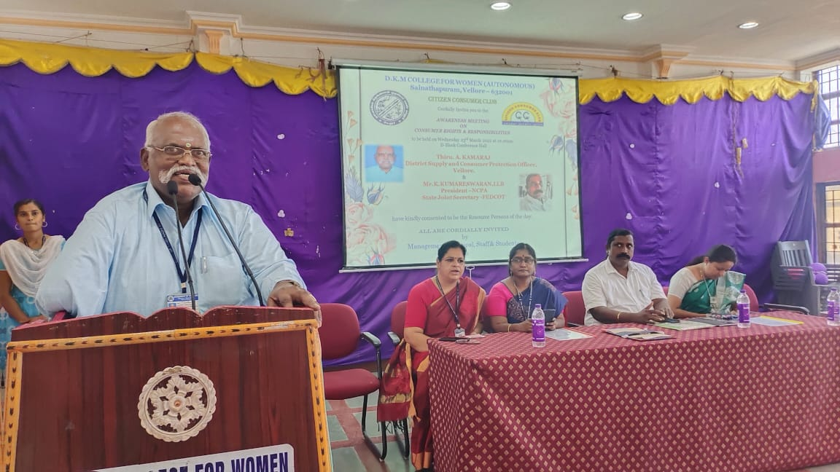
PRESS-PAPER CUTTING
