DETAILS OF PROGRAMME OFFICERS
2020-2021
FOR DAY COLLEGE
Dr.T.Bharathi
Assistant Professor of Commerce
DKM College for Women
Vellore
FOR EVENING COLLEGE
Dr.S.Sasikala
Assistant Professor of Commerce
DKM College for Women
Vellore

YRC SUB COMMITTEE MEETING
AN OVERVIEW
DATE: 05.01.2021

Youth Red Cross of our college conducted YRC Sub Committee Meeting on 10501.2021 at 11.00 am. Dr.P.N.Sudha, Principal and the President of YRC of our college welcomed the gatherings. Dr.R.Padmaja, the senior faculty member, who is interested in social activities attended the meeting and advised us to conduct the YRC programmes relevant to current situation. She also advised us to conduct programme on boosting immunity during pandemic. After certain discussions, the meeting was concluded at 11.45am. The vote of thanks was proposed by Dr.T.Bharathi, YRC programme officer.
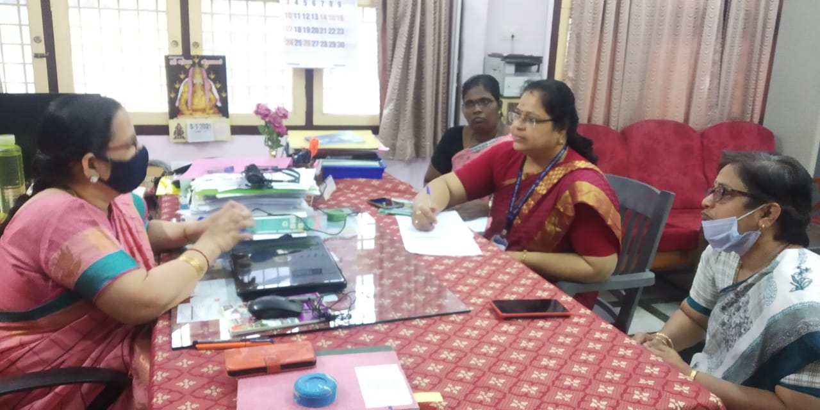

YOUTH DAY CELEBRATIONS
THEME: SWAMI VIVEKANANDA AND HIS MESSAGE
FOR THE YOUTH
AN OVERVIEW
DATE: 12.01.2021
Youth Red Cross of our college celebrated Youth Day on 12.01.2021 at 11.00 am. Welcome address for the programme and the introduction of the resource person was delivered by Dr.T.Bharathi, Assistant Professor of Commerce.
Dr.S.Thamarai Selvi, Assistant Professor of Tamil, DKM College for Women, Vellore acted as resource person and delivered the special address on the theme “Swami Vivekananda and His Message for the Youth” in a very understandable manner to the students. In her speech she highly focused on the messages left by Swami Vivekananda to the younger generation. The session was interesting and thought provoking.
Students were very much impressed upon the programme. The oral feedback from the students was received on the same day and the opinion of the student was ‘Very informative’.
The vote of Thanks for the programme was delivered by Dr.S.Sasikala, Assistant Professor of Commerce.
Nearly 100 students benefited out of this programme.
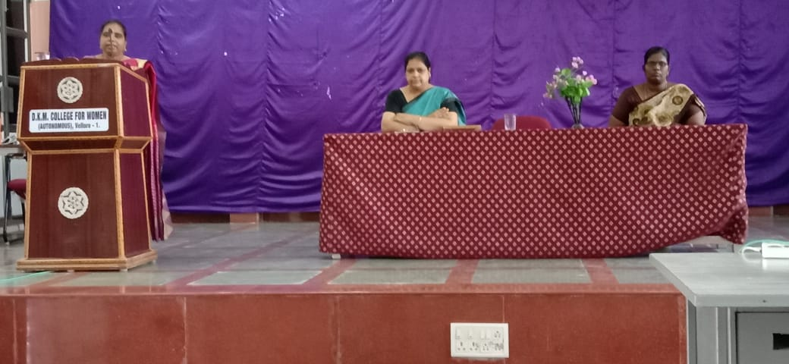
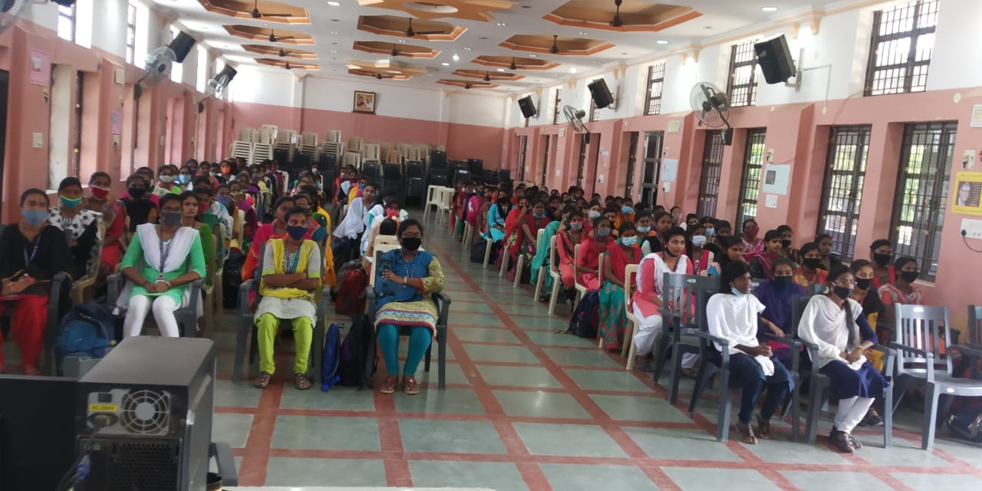

AWARENESS PROGRAMME
THEME: BOOSTING IMMUNITY
AN OVERVIEW
DATE: 19.02.2021
Youth Red Cross of our college organized an awareness programme on the theme “Boosting Immunity” on 19.02.2021 at 11.00 am. Welcome address for the programme and the introduction of the resource persons was delivered by Dr.T.Bharathi, Assistant Professor of Commerce. The felicitation address for the programme was given by Mr.Arul Bagyaraj, Public Relation Officer, Blood Bank, CMC Hospital, Vellore.
Dr.Tamilarasi, Junior Resident, CMC Hospital, Vellore acted as resource person and delivered the special address on the theme “Boosting Immunity during Pandemic” in a very understandable manner to the students. In her speech she highly focused on the food that has to be taken to improve the immunity. Also, she has motivated the students to donate blood. The session was interesting and informative.
Students were very much impressed upon the programme. The oral feedback from the students was received on the same day and the opinion of the student was ‘Very Thought Provoking and Informative’.
The vote of Thanks for the programme was delivered by Dr.S.Sasikala, Assistant Professor of Commerce.
Nearly 100 students benefited out of this programme.
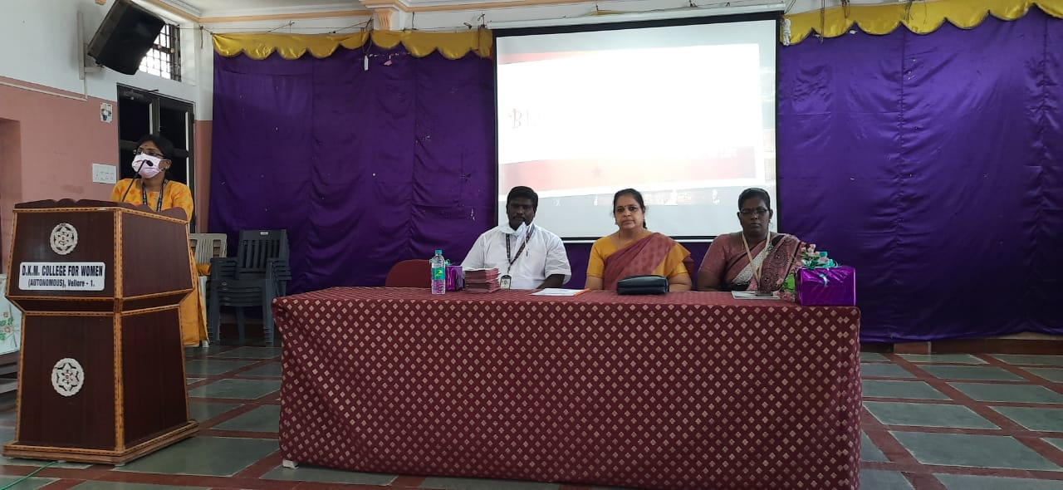
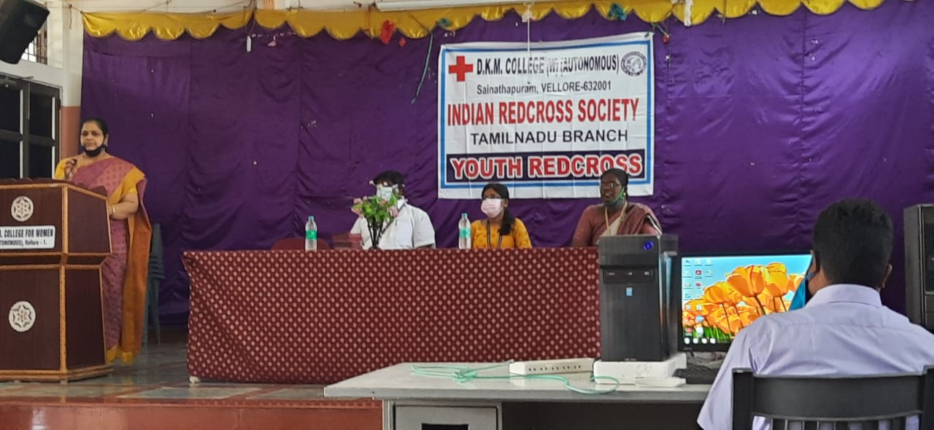

SPECIAL MEETING
THEME: CONSERVATION OF WATER RESOURCES
AN OVERVIEW
DATE: 19.03.2021
Youth Red Cross of our college organized a special meeting on the theme “Conservation of Water Resources” on 19.03.2021 at 11.30 am. Welcome address for the programme and the introduction of the resource person was delivered by Dr.T.Bharathi, Assistant Professor of Commerce.
Dr.G.Shanthi, Assistant Professor of Tamil, DKM College for Women, Vellore acted as resource person and delivered the special address on the theme “Boosting Immunity during Pandemic” in a very understandable manner to the students. In her speech she highly focused on the food that has to be taken to improve the immunity. Also, she has motivated the students to donate blood. The session was interesting and informative.
Students were very much impressed upon the programme. The oral feedback from the students was received on the same day and the opinion of the student was ‘Very Thought Provoking and Informative’.
The vote of Thanks for the programme was delivered by Dr.S.Sasikala, Assistant Professor of Commerce.
Nearly 100 students benefited out of this programme.

