DKM COLLEGE FOR WOMEN(AUTONOMOUS)
VELLORE-1

REPORT ON THE

CITIZEN CONSUMER CLUB(CCC) ACTIVITIES
FOR THE ACAEDEMIC YEAR 2016-17
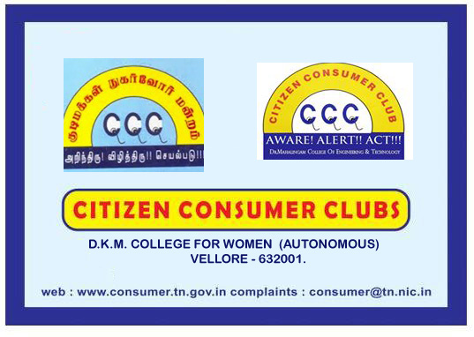

report of ccc activities for the academic year 2016-17

The activities of citizen consumer club of DKM college was inaugurated on 4th July 2016. All the II year B.com students are the members of the CCC. Under the headship of the CCC CO ORDINATOR, DR.S.MYTHILI the activities of the CCC was inaugurated. Ms. Esther Jacklaein, III B.Com, was selected as the student secretary of CCC for this academic year. Mrs. A.Sudarvizhi spoke on the basic concepts, rights and duties of a consumer with a power point presentation. The other events organized were as follows.

DATE | EVENTS ORGANISED | No. of beneficiaries
4. JULY.2016 | Inaugural function of CCC activities for the academic year 2016-17 | 50
8.JULY.2016 | Campus visit of DKM to study the drinking water facilities in the campus | 50
26.AUGUST.2016 | Open discussion on MISLADING ADVERTISEMENTS in the media | 50
30.SEPTEMBER.2016 | A seminar on Consumer Protection Act, 1976 | 50
17.october.2016 | - Students seminar on The effects of junk foods  - Planning the CCC activities for the next semester | 50

PROPOSED FUTURE PLANS OF CCC

- To observe the NATIONAL CONSUMER DAY on December 2016
- To observe the WORLD CONSUMER DAY on march 2017
- To conduct competitions relating to consumer awareness
- If possible, to conduct Inter college CONFEST for two days
- To create consumer awareness among the general public and to issue pamphlets
- To educate the public about the rights and duties of the consumer
- To visit the local ration shop and check the routine work and to find out the mistakes if any
- To arrange for a road rally in the local area educating the public on consumer rights.

The name board of the CCC is already displayed in the entrance of the college in such a way so that not only it is easily visible to all but also educating the students as well as the society about the existence of such important club in our college.
DKM college is supplying RO purified water to the students round the clock. Also we have the provision for Rain Water Harvesting in our college. The cleanliness of the campus is taken care by the members of the Enviro club of DKM college and the members of CCC.

