DKM COLLEGE FOR WOMEN(AUTONOMOUS)
VELLORE-1

REPORT ON THE
CITIZEN CONSUMER CLUB(CCC) ACTIVITIES
FOR THE ACAEDEMIC YEAR 2018-19

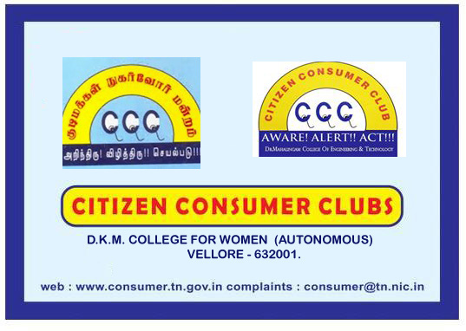

report of the ccc activities for the
academic year 2018-19

The activities of citizen consumer club of DKM college was inaugurated on 4th September 2018. All the B.Com students of Aided pattern are the members of the CCC. Under the headship of the CCC CO ORDINATOR, DR.A.SUDARVIZHI the activities of the CCC was inaugurated. Ms.L.Lavanya , III B.Com, was selected as the student secretary of CCC for this academic year. Dr.T.Bharathi, Assistant Professor of Commerce(Aided) spoke on the basic concepts, rights and duties of a consumer with a power point presentation. The other events organized were as follows.

S.NO | NAME OF THE ACTIVITY | CHIEF GUEST | NO OF BENEFICIARIES | Date
1. | Two days Extension Activity on Consumer Awareness | Commerce Department Staff Members both from Aided & Unaided | 300 | 05.12.2018 and 06.12.2018
2. | Awarness Meeting  On Consumer Rights & Responsibilities | Thiru.Tamil Thirumal, M.A, M.Phil,M.Ed,  PG Assistant(Tamil)  Thiruvalluvar Higher Secondary School, Gudiyattham | 250 | 21.03.2019

EVENT-I
EXTENSION ACTIVITY
AT
GOVERNMENT HIGH SCHOOL
EDAYANCHATHU
VELLORE
05.12.2018 & 06.12.2018

D.K.M COLLEGE FOR WOMEN (AUTONOMOUS)
Sainathapuram, Vellore-632001
DEPARTMENT OF COMMERCE (AIDED)
&
CITIZEN CONSUMER CLUB
Cordially Invites you to the
AWARENESS MEETING
ON
CONSUMER RIGHTS & RESPONSIBILITIES

To be held on Thursday the 21st March 2019
at 10.00 am
at Brahmaputra Conference Hall

Thiru.Tamil Thirumal, M.A, M.Phil, M.Ed
PG Assistant(Tamil)
Thiruvalluvar Higher Secondary School,
Gudiyattham
has kindly consented to be the Resource Person of the day.

All are invited
D.K.M. COLLEGE FOR WOMEN (AUTONOMOUS) VELLORE-01

DEPARTMENT OF COMMERCE (AIDED)
&
CITIZEN CONSUMER CLUB
21.02.2019 (10.00am)
Venue: Brahmaputra Conference Hall

PROGRAMME AGENDA

- Prayer
- Welcome Address
- Felicitation
- Address By The Chief Guest
- Feed Back By Students
- Vote Of Thanks
- National Anthem

Report on the awareness meeting on consumer rights & responsibilities held on thursday the 21st march 2019 at 10.00 am at the brahamaputra hall.

The Department of Commerce(Aided) on behalf of the Citizen Consumer Club conducted an awareness programme of consumer rights & responsibilities on 21.03.2019 Thursday in the Brahamaputra hall. Thiru.Tamil Thirumal, M.A, M.Phil, M.Ed.,
PG Assistant(Tamil), Thiruvalluvar Higher Secondary School, Gudiyatham was the chief guest of the day. He spoke on the trade practices in India in the Tamil Sangam period and highlighted various examples from Tamil literatures. He also stressed the importance of Agriculture in the modern world and emphasized the need for attaining sustainability. Nearly 250 students participated in the meeting. After the feedback from students the meeting ended at 1.00 pm.

Report on the extension activity on consumer awareness organised at government high school, edayanchathu-vellore on 05.12.2018 and 06.12.2018.

On behalf of the Citizen Consumer Club the Department of Commerce both Aided & Unaided organised Two days Extension activity in Government High school Eddayanchathu on Consumer Awareness on 05.12.2018 and 06.12.2018. All the staff members of both aided and unaided pattern were in the team. The Department of Commerce(Aided) organized events on 05.12.2018 while the Department of Commerce(Unaided) organized events on 06.12.2018. The students studying from 6th standard to 10thstandard were the beneficiaries. Essay Competitions , Oratorical Competitions and Painting competitions were conducted to the students on Consumer Awareness. Nearly 73 school students actively participated in the various competitions conducted by us. Our students gave talk on the various precautions to be taken at the time of purchasing a product. Drama was played by our students underlining the need of consumer awareness while purchasing the products. Quiz programme was also conducted for the school students.The winners were given prizes at the end of the programme. On 06.12.2018 four saplings were planted by us in the school campus. After the feedback from the students the extension activity came to a sweet end by 4.30pm .

PHOTOS

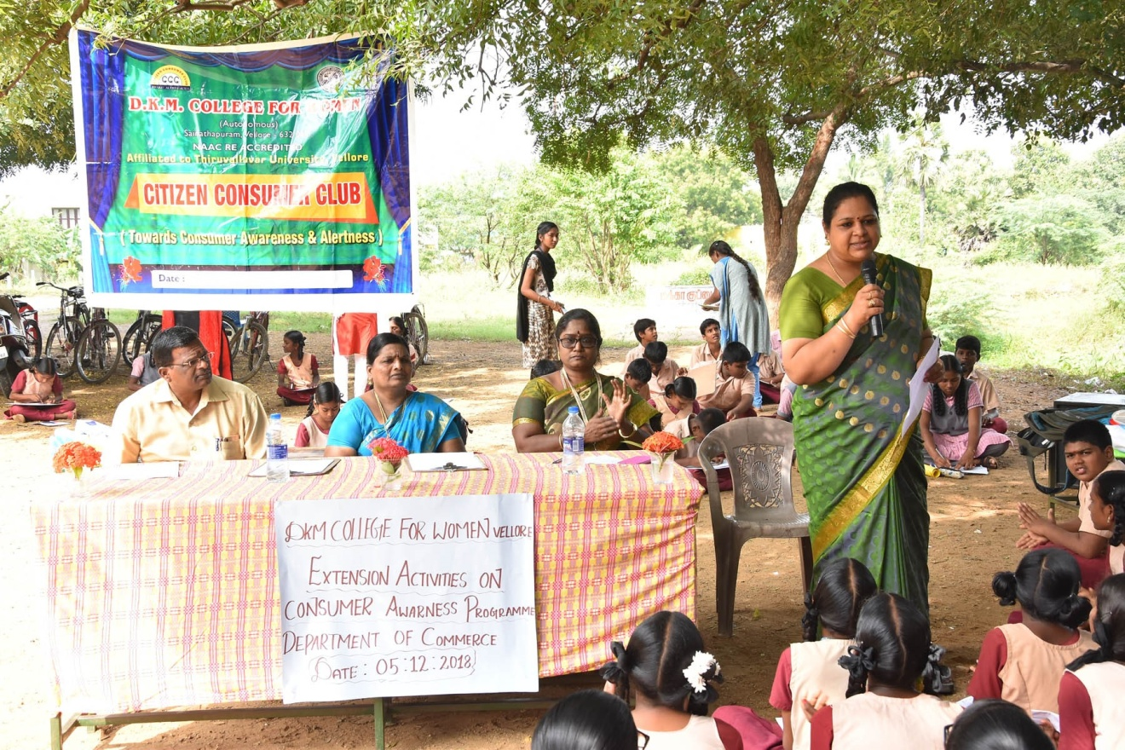
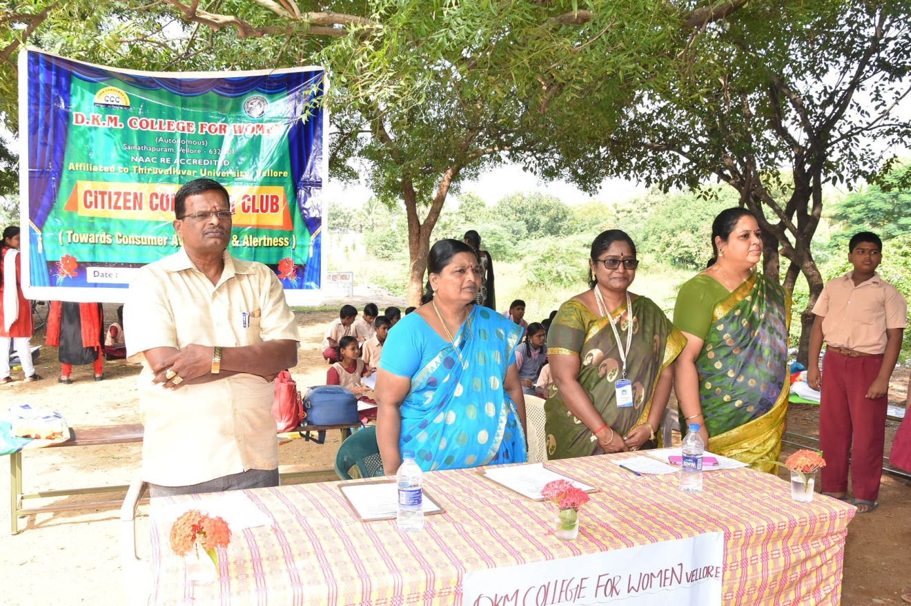
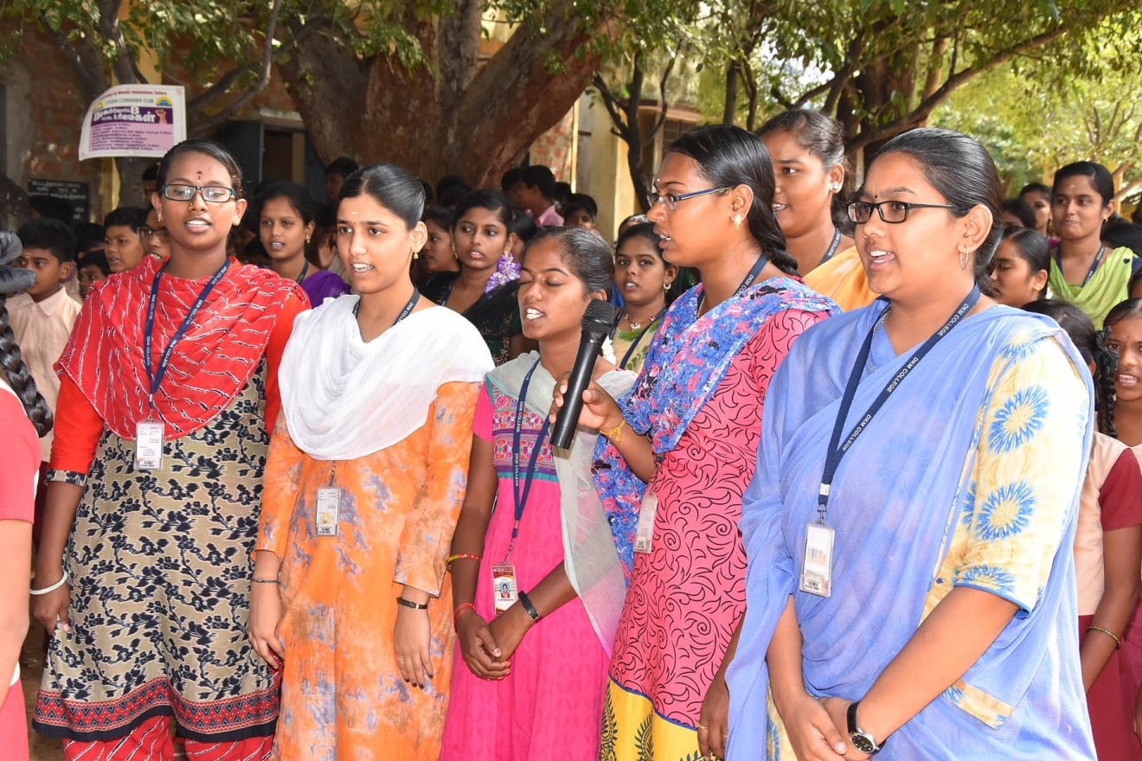
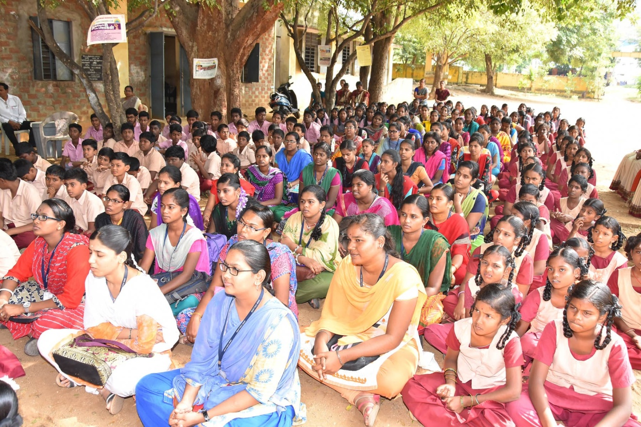
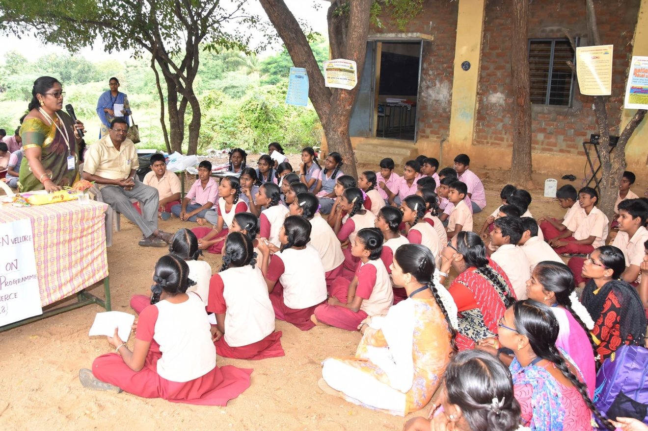
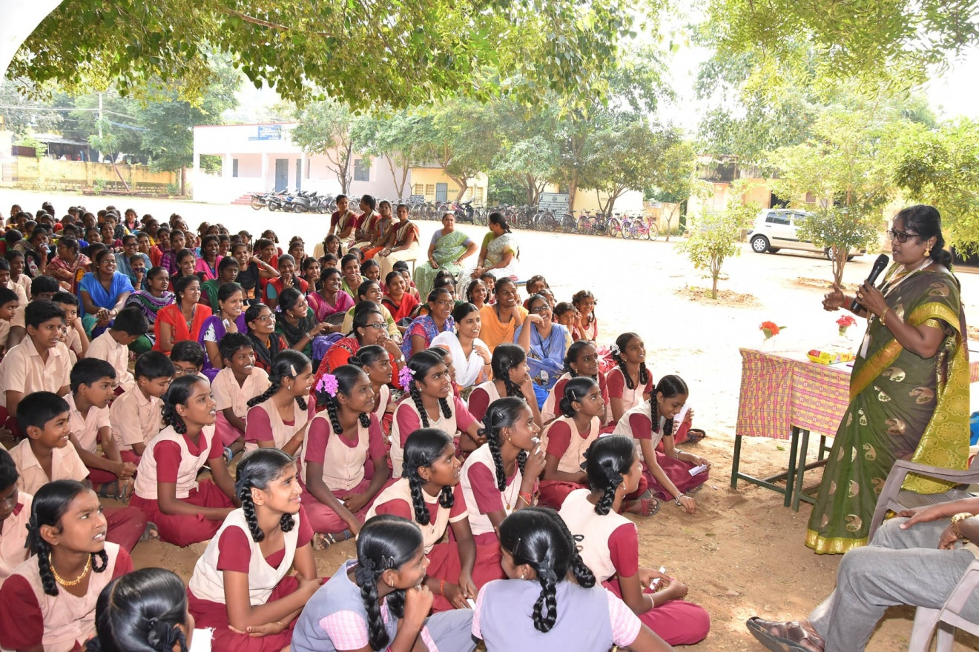
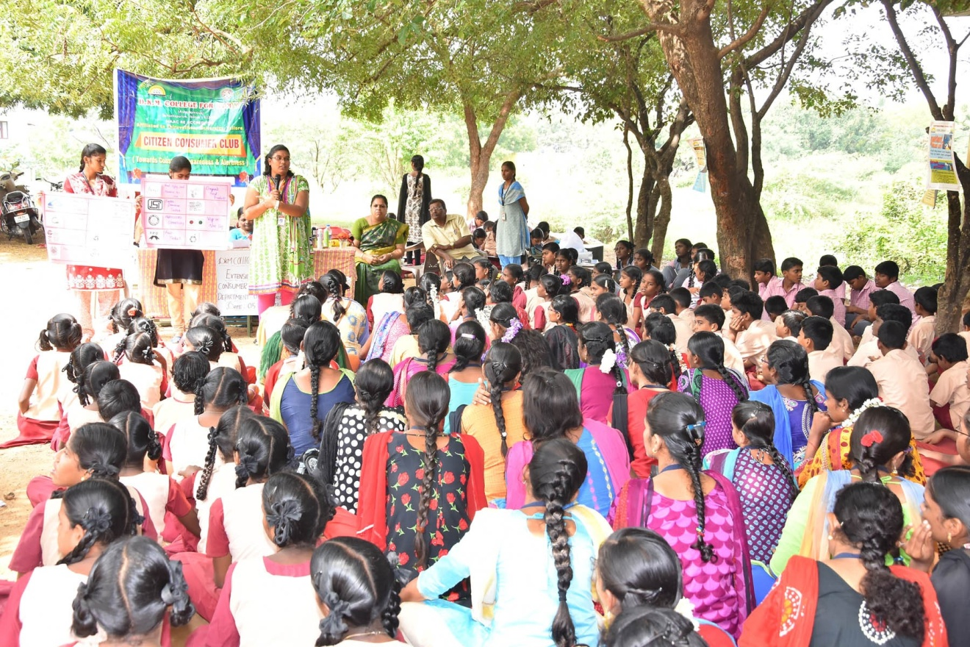
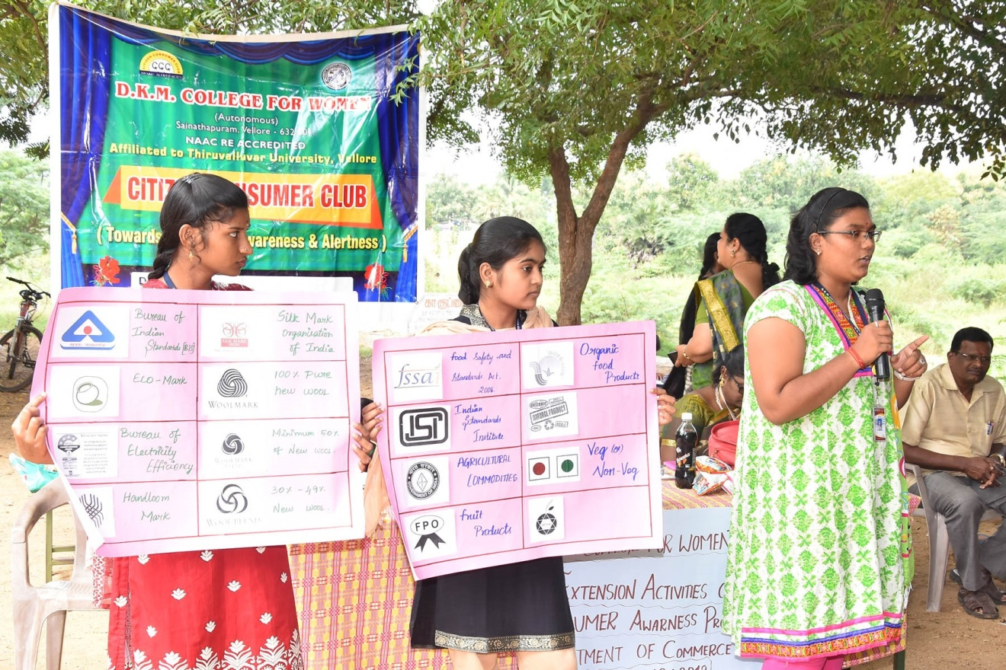
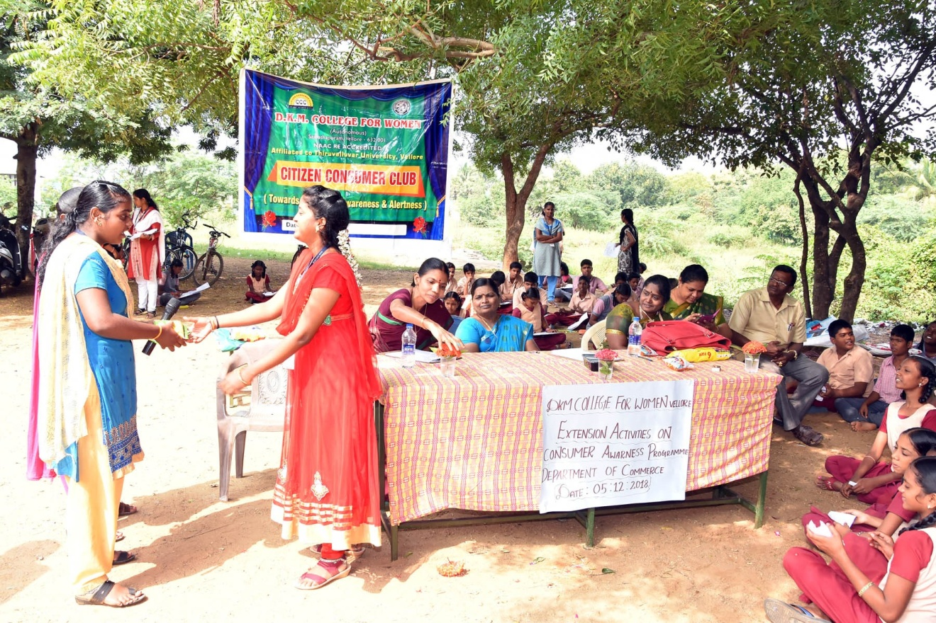
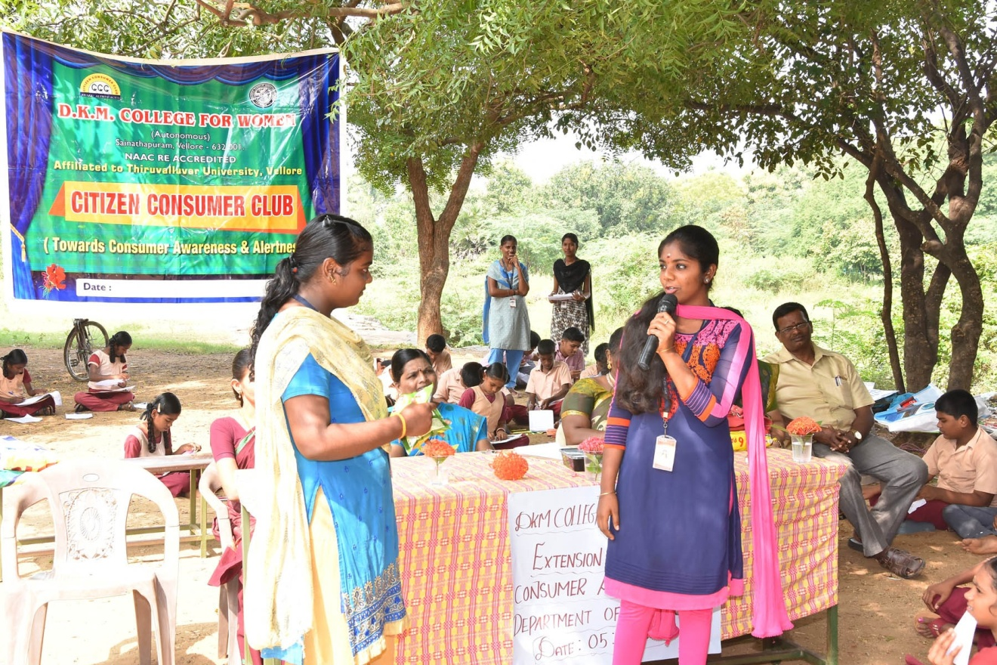

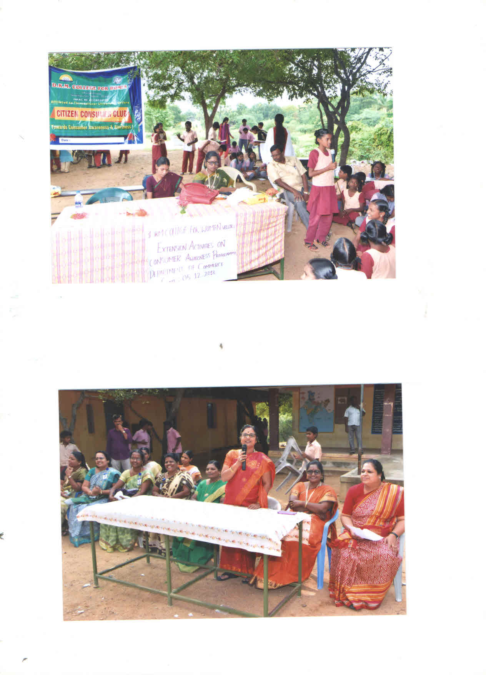

EVENT-II
AWARENESS PROGRAMME
21.03.2019

